Business Process: Small Cell

Contact
Business Process Owner | Billing Solutions
Subject Matter Expert(s) | Sr CSR, Revenue Analyst, Supervisor
Key Contact | Billing Manager, Billing Supervisor
Key Role | Sr. CSR: manage new collective billing request Revenue Analyst: training of collective bill procedure Supervisor: manage assignments
Date Created | 03/03/2026

Business Process Overview
SMUD is working with several Telecommunication Service Providers (TSPs) to add small cell technology to poles in the Sacramento area. These devices may be installed on SMUD or non-SMUD poles to improve wireless service in hard-to-reach areas.

For small cell devices that are installed on public agency facilities, Billing will receive a service request form from the agency and create a service notification to begin the billing enrollment process. Once the service request form is approved, the TSP can begin their construction process, and the agency will notify SMUD once the device is installed to set up billing.

All non-metered small cell devices are billed based on their maximum capacity on the GFN_C rate. Metered small cell devices are billed on the CITS-0 rate. All devices are subject to a monthly Electric O&M fee dependent on the pole type and level of attachment.

Business Process Assumptions, Prerequisites, Dependencies
(Assumptions pertaining to the business process)
People | - Billing CSR’s will be responsible for approving and processing Small Cell Application from various city agencies, setting up new accounts, make changes and/or cancel
Process | - All applications must accompany PE certification letter  - SMUD does not disconnect City Small Cell, Public Agency is to disconnect
Technology | - SAP is used to set up Small Cell accounts  - GIS group to update location specs

Process Flowchart
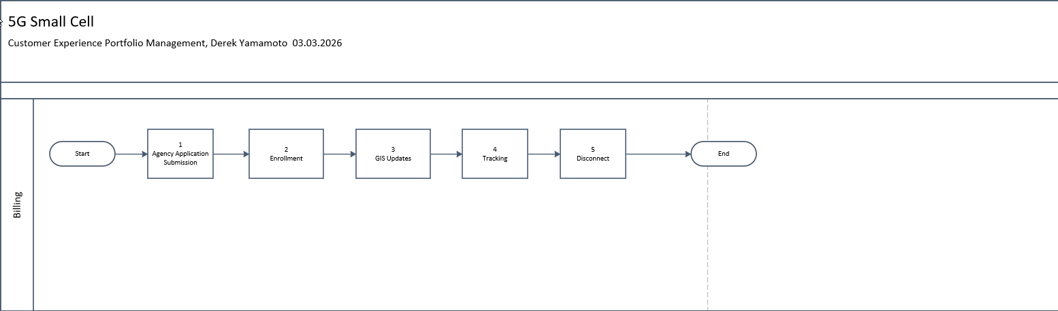

Task Description
Id | Task Description | Procedure
1 | Agency Application Submission | Billing will validate application submission and proper documentation – link to procedure flows below
2 | Enrollment | Billing will follow enrollment process defined in process – link to procedure flows below
3 | GIS Updates | GIS will make updates to geographic locations – link to procedure flows below
4 | Tracking | Billing will follow tracking guidelines – link to procedure flow below
5 | Disconnect | Billing and Agencies will follow defined disconnect process – link to procedure flow below
 | Both procedure maps were validated by and current as of 3/2/2026 | Small Cell City of Sac POC.pdf  Small Cell SMUD POC.pdf

Business Rules
Id | Event Name | Business Rules
 |  | GFN_C rate< 2200w
 |  | CITS-0 rate > 2200w
 |  | SMUD Billing staff – create a service notification for devices installed on an agency POC
 |  | SMUD Design staff – create a service notification for devices installed on a non-agency POC (SMUD Pole)
Metrics:
- Bill staff – 1 day processing time
- GIS staff – 2 days processing time
 |  | Verify that a service request from has been received from the Agency not TSP
 |  | Install/Effective Date is the date the inspection has occurred at the Agency per SMUD agreement

Event | Legal Requirements, Rules, and Regulations  Legal documents/ procedures/ requirements to be fulfilled before/at the specified event.
Id | Event | Legal Requirements, Rules and/or Regulations
 |  | Small Cell Audit Requests.pdf

Departments impacted by process change (Required)

Department | Type of Change(s) | Action Required
Billing | S4Hana | TBD

Supporting Documentation
(Any subsequent documentation in support of this business process (i.e. business requirements, technical specs, etc.) shall be summarized in the following table.)
Document Type | Link
Process and Procedure Document | Small Cell.pdf
 | Small Cell Antennas on SMUD Distribution Poles.pdf
 | Small Cell Log – Access Required
 | City of Sacramento SharePoint Site – Access required
 | Updating Register Group.pdf

Business Blueprint Amendments

Any subsequent changes to this business process blueprint after the official document approval shall be summarized in the following table. This document must be reprinted and signed by the authorized representatives.
Version | Author | Description of Change | Approval (Name/Sign) | Date
V1 | Derek Yamamoto | S4Hana Migration

